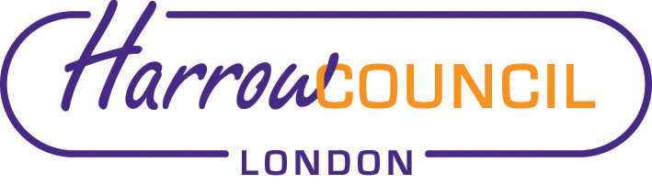
Harrow SACRE Meeting

Tuesday 9 March 2021 at 7.30 p.m.
To be held via video conferencing

Enquiries & apologies to:
Vivian Wright, Clerk to SACRE
vmwright@waitrose.com

Adviser to SACRE: Lesley Prior

Agenda
- Welcome:

- Apologies for absence:

- Minutes of the last meeting on 10 December 2020 (attached): to agree the minutes as a true record.

- Matters arising from the minutes

- RE:GEN presentation

- Local and National Updates including EGM

- Collective Worship Policy - deferred

- Determinations

- Vaughan Determination - deferred

- Priorities for the year ahead

- News from Faith Groups relating to schools

- Any Other Business

- Future Dates

- Tuesday 29 June
- Tuesday 28 September
- Thursday 2 December
- Tuesday 8 March 2022

